Sizes 630 to 910

Direct-drive EC axial fans - AxiBlade with high-performance axial impeller, mounted on a GreenTech EC external rotor motor with integrated control electronics.
Square full nozzle, corrosion-resistant sendzimir galvanized sheet steel, coated with black plastic RAL 9005, optimized inlet ring and optional integrated discharge vanes, aerodynamically optimized guard grill in accordance with DIN EN ISO 13857, made of steel, coated with black plastic RAL 9005.
Profiled blade geometry with winglets at the blade tips; impeller made of highly resistant composite material. Motor impeller statically and dynamically balanced on two planes to balancing grade G 6.3 in accordance with DIN/ISO 21940.
GreenTech EC external rotor motor surpasses efficiency class IE4, magnets with no rare earths, maintenance-free ball bearings with long-term lubrication, theoretical nominal service life of at least 40,000 hours of operation, installation with horizontal and vertical motor shaft, soft start, integrated current limitation, extended voltage input 3~380-480 V, 50/60 Hz, fan can be used with all standard power supply networks without any change in air performance. See data sheet for installation position and temperature range.
Compact electronics; no time-consuming installation work involving shielded wiring; extremely low-noise commutation logic; 100% open-loop speed control, soft start motors, RS485/MODBUS RTU interface; pre-set operating parameters, RFID wireless parameterization, integrated LED status indicator.
Connection via easy-to-install robust integrated terminal box, environmentally resistant cable glands.
Any work required for isolation from structure-borne noise is to be performed by the customer.
Fan satisfies the applicable EMC guidelines and requirements with regard to circuit feedback; documentation and
marking conform to the applicable EU Directives.
Reliable performance data, air performance measurements with guard grill on intake-side chamber test rig according to ISO 5801 and DIN 24163, sound measurements with guard grill in anechoic rooms according to DIN EN ISO 3745.
Conformity with standard EN 61800-5-1; CE, as well as extensive approvals as per UL 1004-7 + 60730; C22.2 No.77 + CAN/CSA-E60730-1 and EAC.

Integrated protective devices:
- Alarm relay with floating contacts (250 V AC/2 A, cos φ = 1)
- Locked-rotor protection
- Phase failure detection
- Line undervoltage detection
- Thermal overload protection for electronics and motor
- Short-circuit protection
- Motor current limitation

Optional:
- Other and specific requirements on request

Technical data:
Fan types ___- ________ - ________ - ____
Air flow q_{V} = ___________________________ m³/h
Static pressure increase p_{fs} = ___________________________ Pa
Overall static efficiency η_{es} = ___________________________ %
Operating speed n = ___________________________ rpm
Motor type = EC motor
Type of control = Closed-loop speed control, 0-100%
Motor efficiency class = IE4
Total power consumption P_{ed} = ___________________________ kW
Specific fan power SFP = ___________________________ kW/(m³/s)
Nominal voltage U_{N} = ___________________________ V
Line frequency f = 50 / 60 Hz
Nominal current I_{N} = ___________________________ A
Protection class = IP55

Sound power level L_{W} A(A, in) = _______ / L_{W}A(A, out) = _______ dB(A)
Sound pressure level (at 1 m) L_{p}A(A, in) = _______ / L_{p}A(A, out) = _______ dB(A)
Perm. ambient temperature T = ____________ to ____________ °C
Weight of fan m = ___________________________ kg

Product photo
EC axial fans – AxiBlade
System with guide vanes System without guide vanes
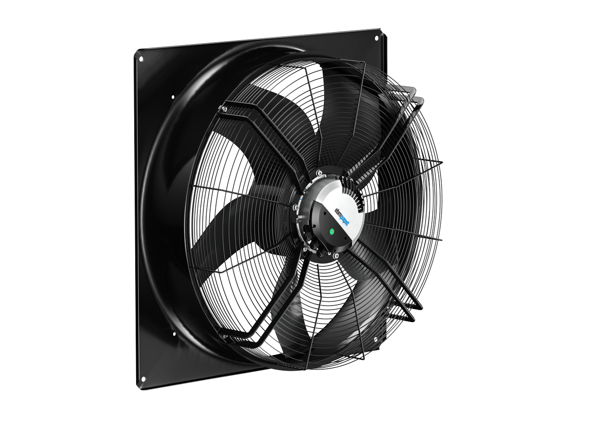

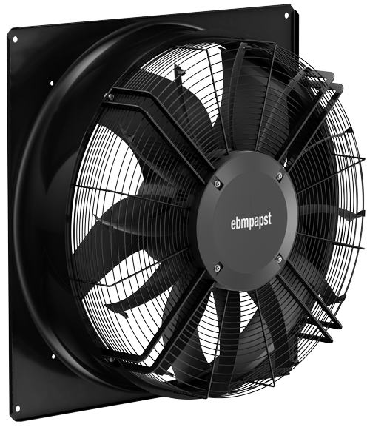

Refer to data sheet for technical data, dimensions and connections

