EC centrifugal fans – RadiFit
Sizes 250 to 400
Direct-drive dual-inlet centrifugal fans with backward-curved high-performance centrifugal impellers mounted on a GreenTech EC external rotor motor with add-on control electronics.
Scroll housing made of galvanised sheet steel with bolted-on adjustable mounting bracket, optimised step diffuser in discharge for low-noise operation, connection flange on pressure side.
Aluminium impeller with 7 backward-curved, offset, continuously welded blades. Flow-optimised inlet nozzle made of galvanised sheet steel.
Motorised impeller balanced in two planes (static and dynamic) as per DIN ISO 1940 to balance quality G 6.3.
GreenTech EC external rotor motor surpasses efficiency class IE4, magnets without use of rare earths, maintenance-free ball bearings with long-term lubrication, theoretical nominal service life of at least 40,000 operating hours, soft start, integrated current limitation, wide input voltage range 3-phase 380-480 V, 50/60 Hz, fan suitable for use with all standard power supply systems with no effect on air performance. Motorised impeller isolated from surroundings with specially designed vibration-absorbing elements, compact electronics, aluminium housing, low-noise commutation logic; 100% speed control; PID controller; RS485/MODBUS RTU interface, no need for shielded wiring.
Readily accessible connection area with spring terminals, cable entry can be moved through 180 degrees, environment-resistant cable glands.
Fan satisfies the relevant EMC regulations and requirements with regard to circuit feedback; documentation and marking conform to the applicable EU directives.
Reliable performance data, air performance measurements on inlet-side chamber test rig in accordance with ISO 5801 and DIN 24163, noise measurements in low-reflection acoustic test chamber as per DIN EN ISO 3745.

Integrated protective devices:
- Alarm relay with floating contacts (250 V AC/2 A, cos φ = 1)
- Locked-rotor protection
- Phase failure detection
- Motor soft start
- Mains undervoltage detection
- Excess temperature protection for electronics and motor
- Short circuit protection

Optional:
- Different requirements on request

Technical data:
Fan types D3G ________ - ________ - _____
Air flow q_{V} = ___________________________ m³/h
Stat. pressure increase p_{fs} = ___________________________ Pa
Stat. overall efficiency η_{es} = ___________________________ %
Operating speed n = ___________________________ min⁻¹
Motor type = EC motor
Type of control = 0-100% speed control
Motor efficiency class = IE4
Total power consumption P_{ed} = ___________________________ kW
Specific fan power SFP = ___________________________ kW/(m³/s)
Nominal voltage range U_{N} = ___________________________ V
Mains frequency f = 50 / 60 Hz
Nominal current I_{N} = ___________________________ A
Ingress protection = IP54
Sound power level L_{W} A(A, in) = _______ / L_{W}A(A, out) = _______ dB(A)
Sound pressure level (at 1 m) L_{p}A(A, in) = _______ / L_{p}A(A, out) = _______ dB(A)
Perm. ambient temperature T = ____________ to ____________ °C
Fan mass m = ___________________________ kg

Product photo
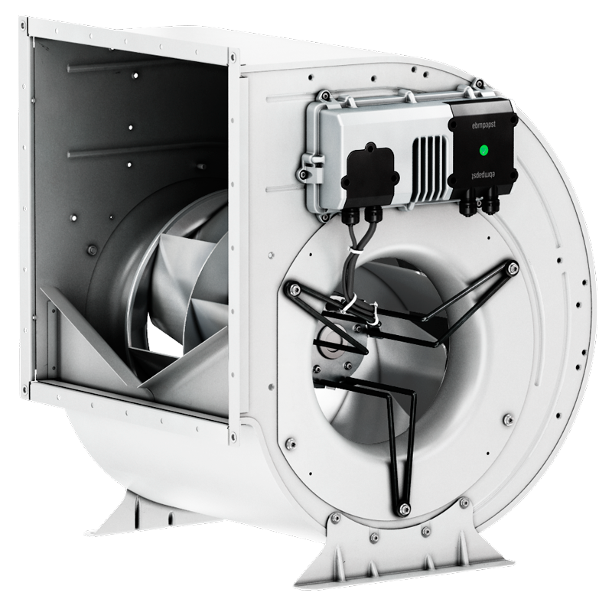
EC centrifugal fans – RadiFit D3G400

Refer to data sheet for dimensions and connections

