RadiCal DC centrifugal fans
Sizes 190 to 280

Direct-drive, single inlet centrifugal fans with backwards-curved high-performance centrifugal impellers with radial diffusors, based on a GreenTech EC external rotor motor with integrated control electronics.
Impeller made of glass-fiber reinforced plastic, with backwards-curved blades, manufactured in one piece without seams.
Motor impeller statically and dynamically balanced on two planes to balancing grade G 6.3 in accordance with DIN ISO 1940.
GreenTech EC external rotor motor surpasses efficiency class IE4, magnets with no rare earths, maintenance-free ball bearings (sealed) with long-term lubrication, theoretical nominal service life of at least 40,000 hours of operation, installation with horizontal and vertical motor shaft; soft start, integrated current limitation. Voltage range 8-16 V, 16-28 V, 36-57 V; Integrated electronics, quiet commutation logic; 100 % speed controllable; control signal 0-10 V DC / PWM; tach output.
Cable connection with protruding, pre-assembled, variable cable, with wire-end ferrules, UV-resistant, water impermeable.
Any work required for isolation from structure-borne noise to be performed by the customer.
Fan satisfies the applicable EMC guidelines and requirements with regard to circuit feedback; documentation and marking conform to the applicable EU Directives. UL 507 approval.
Reliable performance data, air performance measurements in intake-side test chamber according to ISO 5801 and DIN 24163, sound measurements in an anechoic test chamber in accordance with DIN EN ISO 3745.

Integrated protective devices:
- Reverse polarity and locked-rotor protection
- Overvoltage detection
- Soft start
- Motor current limitation
- Thermal overload protection

Optional:
- Other and specific requirements on request

Technical data:
Fan type R1G ________ - ________ - _____
Air flow q_{V} = ___________________________ m³/h
Actual pressure increase p_{fs} = ___________________________ Pa
Overall static efficiency η_{ed} = ___________________________ %
Operating speed n = ___________________________ rpm
Motor type = DC motor
Control type = 0-10 VDC, 0-100% PWM
Motor efficiency class = IE4
Total power consumption P_{ed} = ___________________________ kW
Specific fan power SFP = ___________________________ kW/(m³/s)
Nominal voltage range U_{N} = ___________________________ V
Nominal current I_{N} = ___________________________ A
Protection class = IP 24 KM (motor); electronics IP 66/69 K
Sound power level L_{W} A(A, in) = _______ / L_{W}A(A, out) = _______ dB(A)
Sound pressure level (at 1 m) L_{p}A(A, in) = _______ / L_{p}A(A, out) = _______ dB(A)
Permitted ambient temperature T = _______________ to _______________ °C
Weight of fan m = ___________________________ kg

Product photo
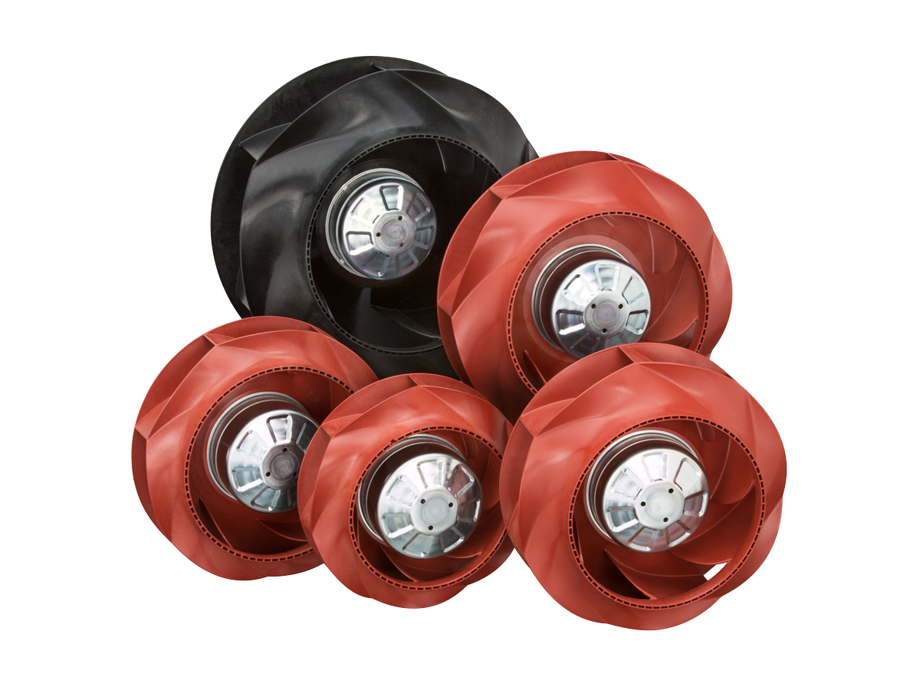

RadiCal DC centrifugal fans

For dimensions and connections, see data sheet

