EC axial fans - HyBlade®
Sizes 200 to 450

Direct-drive EC axial fans - HyBlade® with high-performance axial impeller, mounted on a GreenTech EC external rotor motor with integrated control electronics.
Round full nozzle, pre-galvanised, black plastic-coated RAL 9005, flow-optimised nozzle shape on inlet side, guard grille made of phosphated steel and black plastic-coated.
Sickle-shaped blades; one-piece impellers made of fibre glass-reinforced plastic PP; winglets at the blade tips. Motorised impeller balanced in two planes (static and dynamic) as per DIN ISO 1940 to balance quality G 6.3.
GreenTech EC external rotor motor surpasses efficiency class IE4, magnets without use of rare earths, maintenance-free ball bearings with long-term lubrication, theoretical nominal service life of at least 40,000 operating hours, installation with horizontal and vertical motor shaft; soft start, integrated current limitation, wide input voltage range
1-phase 200-240 V, 50/60 Hz, fan suitable for use with all standard power supply systems with no effect on air performance. Designed for operating mode S1 (continuous operation). Refer to data sheet for installation position and temperature range.
Compact electronics; no need to install shielded wiring; extremely low-noise commutation logic; pre-set operating parameters, no parameterisation work required.
Standard cable design.
Any work required to prevent the transmission of structure-borne noise is to be performed by the customer.
Fan satisfies the relevant EMC regulations and requirements with regard to circuit feedback; documentation and marking conform to the applicable EU directives.
Reliable performance data, air performance measurements on inlet-side chamber test rig in accordance with ISO 5801 and DIN 24163, noise measurements in low-reflection acoustic test chamber as per DIN EN ISO 3745.

Integrated protective devices:
- Locked-rotor protection
- Motor soft start
- Excess temperature protection for electronics and motor
- Short circuit protection
- Motor current limit
- Protection rating: M3G 055/074 IP 54 (as per EN 60529)
- Protection rating: M3G 084 IP 55

Optional:
- Different and specific requirements on request

Technical data:
Fan types ___- ________ - ________ - ___
Air flow q_{V} = ___________________________ m³/h
Stat. pressure increase p_{fs} = ___________________________ Pa
Stat. overall efficiency η_{es} = ___________________________ %
Operating speed n = ___________________________ min⁻¹
Motor type = EC motor
Type of control 0-10VDC/PWM
2 speed levels
Motor efficiency class = IE4
Total power consumption P_{ed} = ___________________________ kW
Specific fan power SFP = ___________________________ kW/(m³/s)
Nominal voltage range U_{N} = ___________________________ V
Mains frequency f = 50 / 60 Hz
Nominal current I_{N} = ___________________________ A
Protection class M3G 055/074 = IP54
Protection class M3G 084 = IP55

Sound power level L_{W} A(A, in) = _______ / L_{W}A(A, out) = _______ dB(A)
Sound pressure level (at 1 m) L_{p}A(A, in) = _______ / L_{p}A(A, out) = _______ dB(A)
Perm. ambient temperature T = ____________ to ____________ °C
Fan mass m = ___________________________ kg

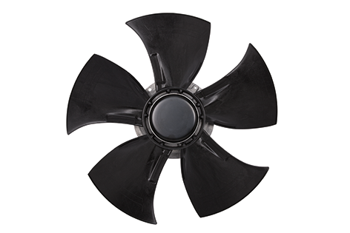
Product photo
EC axial fans - HyBlade®

Direction of air flow "V"
A (without attachments); S (with guard grille for short nozzle); W (with round full nozzle)



Refer to data sheet for dimensions and connections

