EC medium pressure axial fan
Sizes 1120 to 1600

Direct-drive EC medium pressure axial fan with high-performance axial impeller with hub, mounted on a GreenTech EC external rotor motor with integrated control electronics.
Double-flange housing made of galvanised sheet steel, flow-optimised nozzle shape on inlet side, corrosion protection as per DIN EN ISO 12944, class C5 M; transport loops for safe handling during shipping and installation.
Impeller and hub made of die-cast aluminium, with flow-optimised Airfoil blade geometry, blade angle and number of blades specified at the factory to suit the required operating point; installation possible on inlet or pressure side; motorised impeller balanced in two planes (static and dynamic) as per DIN ISO 1940 to balance quality G 6.3.
GreenTech EC external rotor motor surpasses efficiency class IE4, magnets without use of rare earths, maintenance-free ball bearings with long-term lubrication, theoretical nominal service life of at least 40,000 operating hours, installation with horizontal and vertical motor shaft; soft start, integrated current limitation, wide input voltage range 3-phase 380-480 V, 50/60 Hz, fan suitable for use with all standard power supply systems with no effect on air performance.
Compact electronics; no need to install shielded wiring; extremely low-noise commutation logic; 100% speed control, with PID controller; RS485/MODBUS RTU interface; pre-set operating parameters, no parametrisation work required.
Terminal box made of aluminium with readily accessible connection area with spring terminals, environment-resistant cable glands.
Any work required to prevent the transmission of structure-borne noise is to be performed by the customer.
Fan satisfies the relevant EMC regulations and requirements with regard to circuit feedback; documentation and marking conform to the applicable EU directives.
Reliable performance data, air performance measurements on inlet-side chamber test rig in accordance with ISO 5801 and DIN 24163, noise measurements in low-reflection acoustic test chamber as per DIN EN ISO 3745.

Integrated protective devices:
- Alarm relay with floating contacts (250 V AC/2 A, cos φ = 1)
- Locked-rotor protection
- Phase failure detection
- Motor soft start
- Mains undervoltage detection
- Excess temperature protection for electronics and motor
- Short circuit protection

Optional:
- Different and specific requirements on request

Technical data:
Fan types W3G ________ - ________ - _____
Air flow q_{V} = ___________________________ m³/h
Stat. pressure increase p_{fs} = ___________________________ Pa
Stat. overall efficiency η_{es} = ___________________________ %
Operating speed n = ___________________________ min⁻¹
Motor type = EC motor
Type of control = 0-100% speed control
Motor efficiency class = IE4
Total power consumption P_{ed} = ___________________________ kW
Specific fan power SFP = ___________________________ kW/(m³/s)
Nominal voltage range U_{N} = ___________________________ V
Mains frequency f = 50 / 60 Hz
Nominal current I_{N} = ___________________________ A
Ingress protection = IP54
Sound power level L_{W} A(A, in) = _______ / L_{W}A(A, out) = _______ dB(A)
Sound pressure level (at 1 m) L_{p}A(A, in) = _______ / L_{p}A(A, out) = _______ dB(A)
Perm. ambient temperature T = ____________ to ____________ °C
Fan mass m = ___________________________ kg

Product photo
EC axial fan – straight blades W3G…

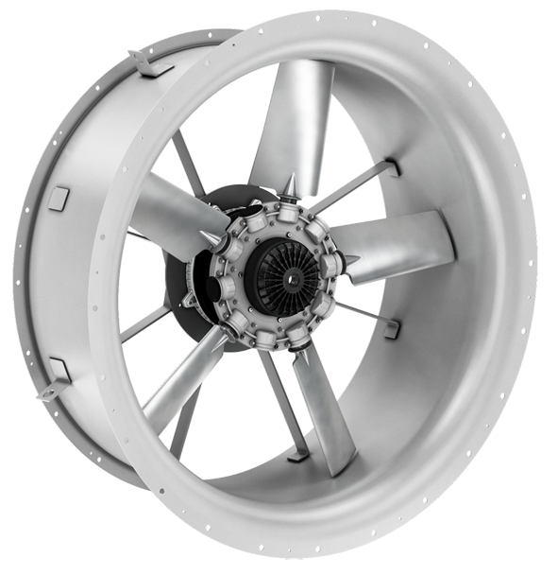

Refer to data sheet for dimensions and connections

