Stronger Together: ebm-papst and PETRA Elevate Strategic Partnership

Mulfingen, Germany — November 17th, 2025

ebm-papst, the world’s leading manufacturer of fans and motors, and Petra Engineering Industries Co., Ltd. (PETRA) have strengthened their collaboration with a new strategic partnership. Founded in 1987 and headquartered in Amman, Jordan, PETRA is a market leader in the design and manufacture of high-quality commercial and industrial HVAC equipment, serving datacenter and industrial clients with advanced solutions.

Under this enhanced partnership, PETRA is designated as a Group Account within the ebm-papst organization, ensuring dedicated management, prioritized service, and seamless global coordination. PETRA will have first-choice access to ebm-papst EC fans for all datacenter-related applications, reflecting mutual trust and long-term commitment. The collaboration also provides PETRA with reliable supply assurance and dedicated engineering support — including technical consultancy, performance testing, and simulation services — enabling tailored, high-performance solutions and faster innovation for the datacenter market.

For ebm-papst, the partnership reinforces its leadership in high-efficiency datacenter cooling solutions, broadens market presence, and deepens insight into customer needs. PETRA has agreed that ebm-papst EC fans will be the first choice for all datacenter-related business activities, reflecting the trust and strategic alignment between both companies.

Thomas Nuernberger, CSO of the ebm-papst Group and President & CEO of Air Technology APAC & MEA, said: “Our partnership with PETRA reflects the principle of ‘making the future together.’ It strengthens our strategic position and allows us to deliver innovative, high-performance solutions for datacenter applications.”

Omar Abu Wishah, Vice Chairman of PETRA Engineering, added: “This strategic partnership marks a new chapter in our collaboration with ebm-papst. Together, we are committed to driving innovation and expanding our business in the datacenter sector.”

Image (source: PETRA): ebm-papst and Petra Engineering representatives at the signing ceremony of their Strategic Partnership Agreement. (From left to right: Thomas Nuernberger, Omar Abu Wishah, and Omar Ali)
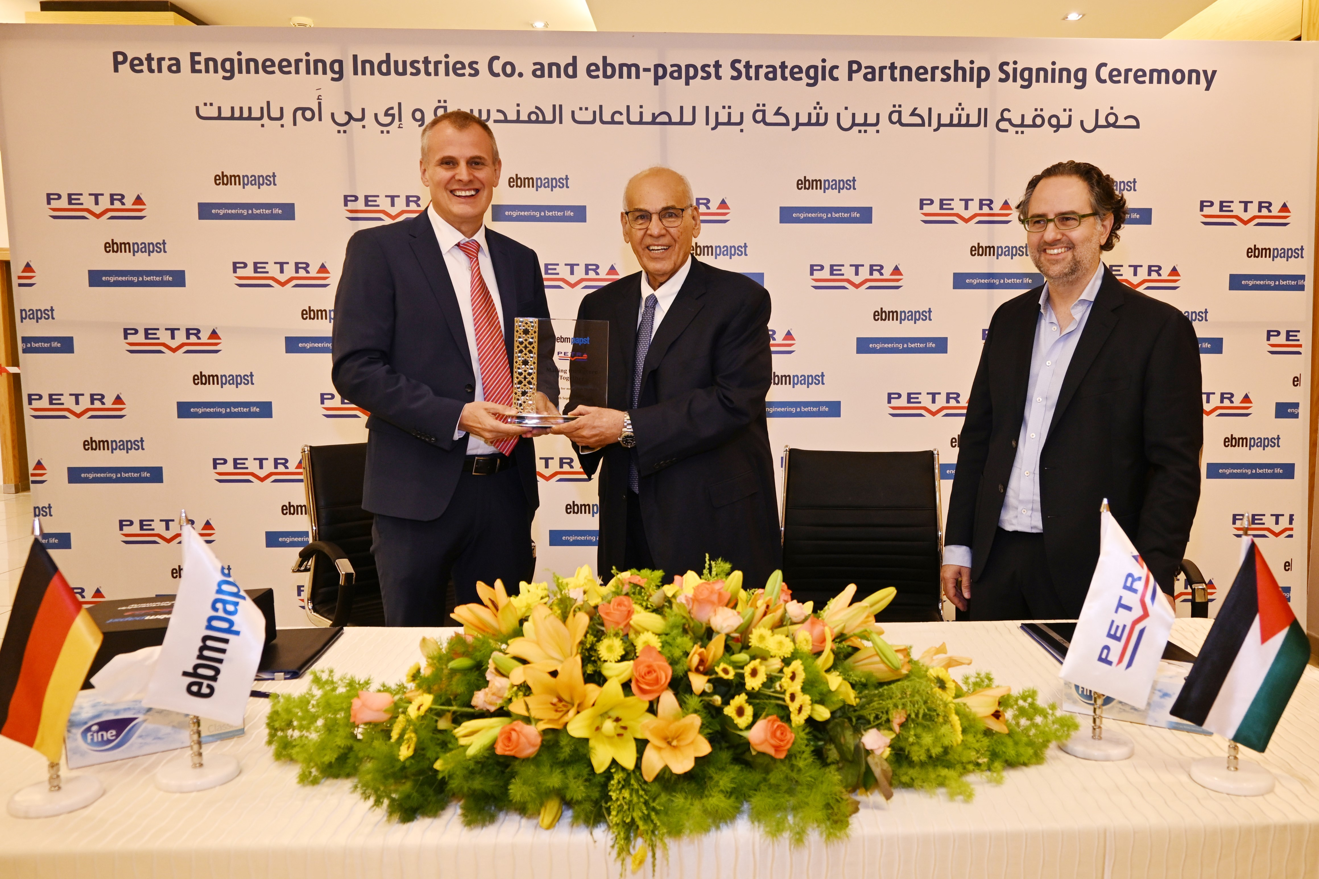

About ebm-papst

The ebm-papst Group, a family-run company headquartered in Mulfingen, Germany, is the world’s leading manufacturer of fans and motors. Since it was founded in 1963, the technological leader has set international industry standards with its core competencies in motor technology, electronics, digitalization, and aerodynamics.

ebm-papst offers sustainable, intelligent, and tailor-made solutions for virtually every requirement in ventilation and heating technology. ebm-papst sets the benchmark in almost all sectors, such as ventilation, air conditioning and refrigeration technology, heating technology, information technology, mechanical engineering, and medical technology.
In the 2024/25 financial year, the Group generated a turnover of EUR 2.1 billion. It employs just nearly 13,500 people at 25 production sites including in Germany, China, and the US, as well as around 50 sales offices worldwide.

APAC & MEA Press Office
Witty Zhang
Marketing Director APAC & MEA
ebm-papst China
TEL: 021-50460183*316
Juejuan.Zhang@cn.ebmpapst.com

Daisy Li
Corporate Communications Specialist
APAC & MEA
ebm-papst China
TEL: 021-50460183*288
danyang.li@cn.ebmpapst.com

